CS223 UART DESIGN PROJECT

Name: Barış Pamuksuz
ID: 22202238
Section: 1

TASK 1: DESIGN AND FUNCTIONALITY
Main UART (part 1) requires basically TX and RX buffers implementation. To establish same bit sending-receiving, same period should be used. Period is determined by the baud rate, that I took 115200 in my code. Hence CLKS_PER_BIT is 100Mhz/115200 = 868, meaning that at the end of 868 cycle, new bit is sent or obtained. Both of buffers have 4 states. They are idle, start, get/send bit and stop states. For TX buffer, when state is Idle, logic is 1. Whenever user press BTNC, TX goes to start state and sends 0 signal to RX buffer. Since RX buffer too was in idle state, incoming 0 signal initiates state cycling by moving start state to be able to receive a byte. RX and TX buffers move into get bit and send bit states respectively. After sending data, RX checks the parity bit generated by TX according to number of 1s. In my case, I used even parity. If income data holds even number of 1s and 0 as parity or odd number of 1s and 1 as parity, data receive is completed and transmitted to stop state that is in logic high signal. After a while, again, returned to idle state for both buffers.
In second part, FIFO registers are completed by defining 32-bit memories for both buffers. For TX, when loadButton is pressed, new data is loaded to first 8 bits, that is TX[0], and TX[3] is discarded with the convention that rest of data are sided by one to the right. Discarded data is sent through state mechanism to RX. For RX, after get bit state, that is completing a 8 bit sequence successfully, obtained data is set to RX[0] and R[3] is discarded with the convention of moving income data by one to the right. Since button inputs might cause noise or unwanted input streams, I implemented button debounce to ensure pushing on button generates 1 signal not constantly.
In third part, to get hexadecimal values of data inside memories, I divided each byte into 2 nibbles. Each nibble corresponding to later displayed hexadecimal symbols. Other 2 digits are assigned to determine in which memory location 7-segment-display shows and the index of data inside those memories.

TASK 2: RTL SCHEMATICS
TX RTL
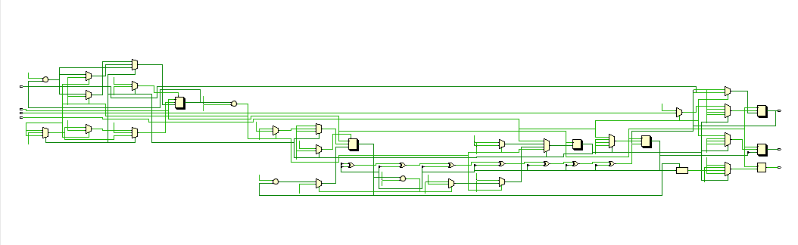
RX RTL
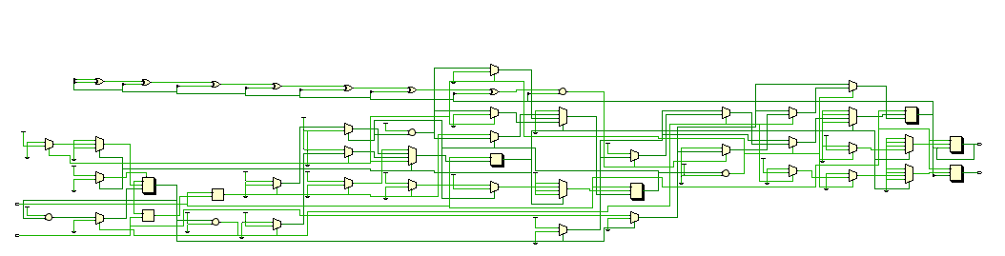
7SegmentDisplay RTL
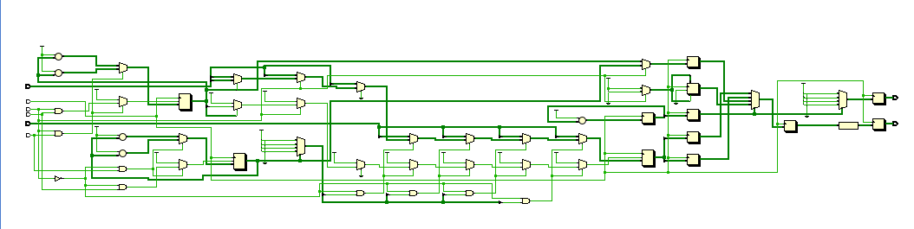
TASK 3: STATE DIAGRAMS
RX
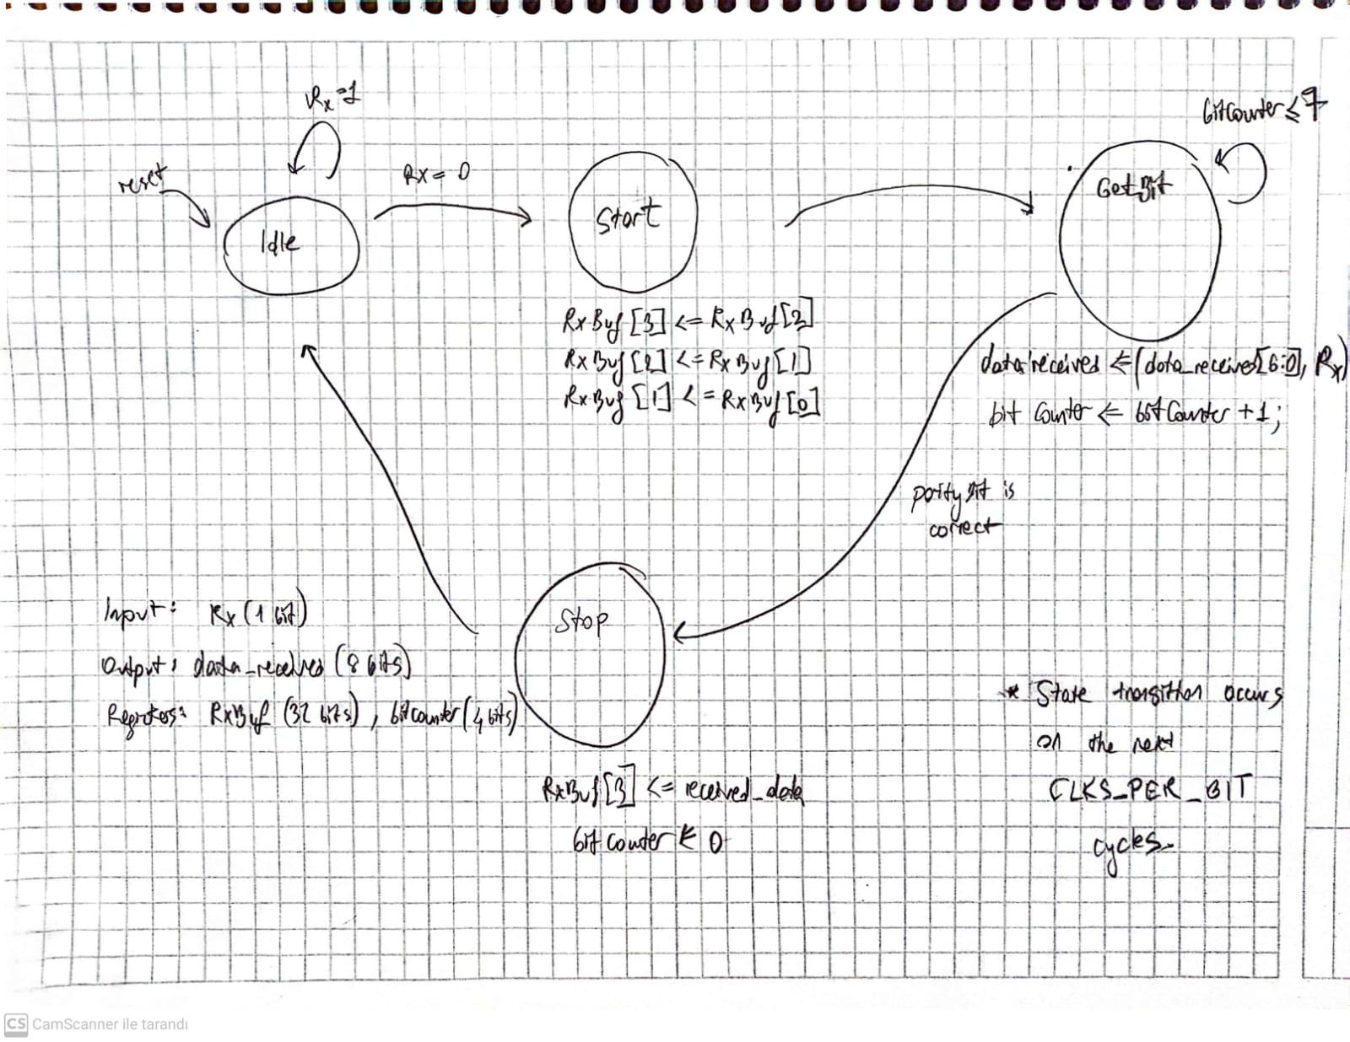
TX
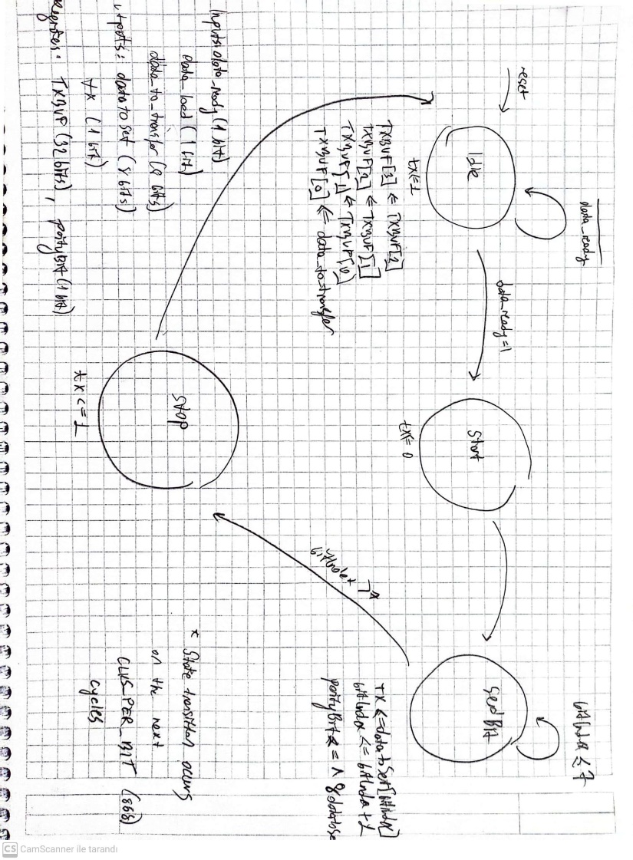
TASK 4: BLOCK DIAGRAM FOR EACH MODULES
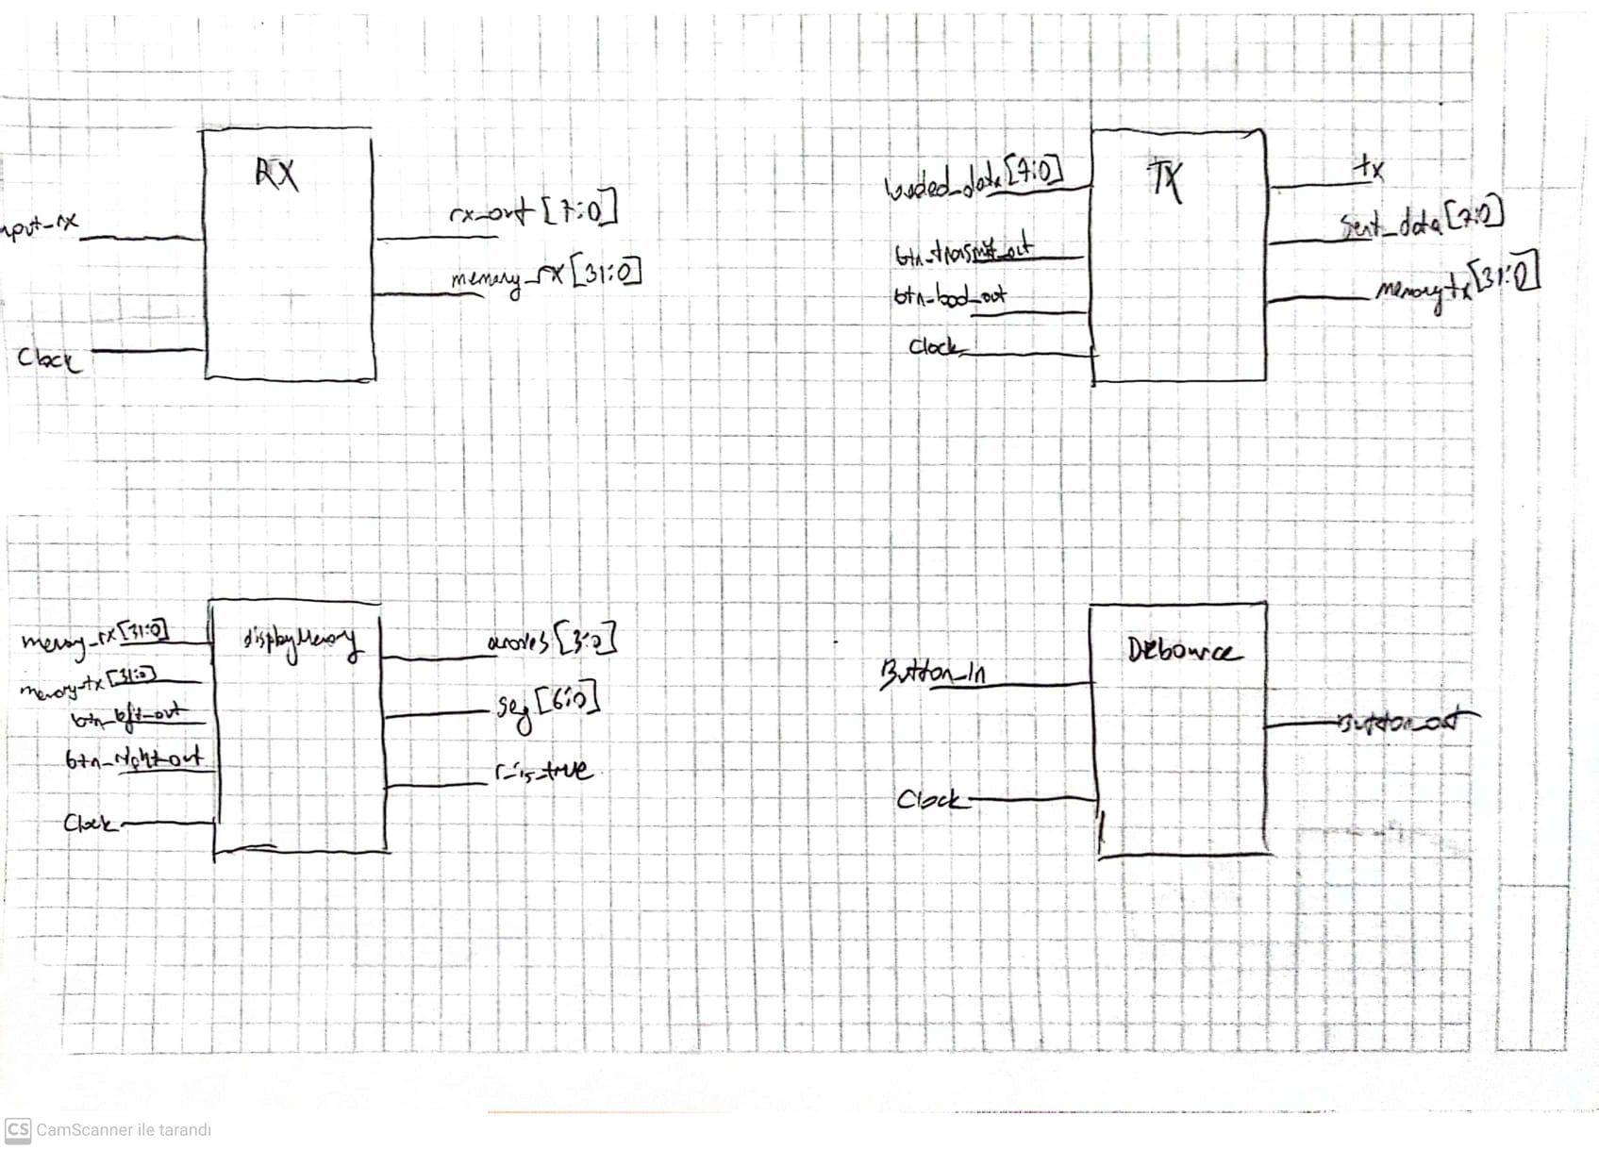
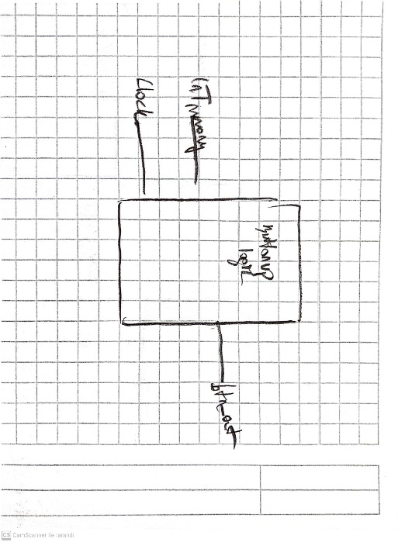

TASK 5: TESTBENCH RX – TX
TESTBENCH TX MODULE
`timescale 1ns / 1ps

module testbench;

reg [7:0] data_to_Transfer;
reg data_ready;
reg loadButton;
reg clock;
wire tx;
wire[7:0] mostRecent; // Assuming this is also an output now

Uart_tx uart_tx_inst (
.data_to_Transfer(data_to_Transfer),
.data_ready(data_ready),
.loadButton(loadButton),
.clock(clock),
.tx(tx),
.mostRecent(mostRecent) // Assuming these are correctly declared as outputs in the Uart_tx
);

// Clock generation
initial begin
clock = 0;
forever #5 clock = ~clock;
end

// Test sequence
initial begin
// Initialize inputs
data_to_Transfer = 0;
data_ready = 0;
loadButton = 0;

#100;

// Test 1: Load data into FIFO
@(posedge clock);
data_to_Transfer = 8'hAA; // Example data
loadButton = 1;
@(posedge clock);
loadButton = 0;

// Test 2: Load another data
@(posedge clock);
data_to_Transfer = 8'hBB; // Example data
loadButton = 1;
@(posedge clock);
loadButton = 0;

// Test 3: Load additional data while sending
repeat(10) @(posedge clock);
data_to_Transfer = 8'hDD;
loadButton = 1;
@(posedge clock);
loadButton = 0;

// Test 4
repeat(5) @(posedge clock);
data_to_Transfer = 8'hEE;
loadButton = 1;
@(posedge clock);
data_to_Transfer = 8'hFF;
@(posedge clock);
loadButton = 0;

repeat(10) @(posedge clock);
data_ready = 1;
@(posedge clock);
data_ready = 0;

#100
@(posedge clock);
loadButton = 1;
@(posedge clock);
loadButton = 0;
// Continue simulation to observe full behavior
#200;

// End simulation
$finish;
end
endmodule
TESTBENCH RX MODULE
`timescale 1ns / 1ps

module testbench2;

reg i_rx;
reg clock;
reg [7:0] memoryR;

Uart_rx uart_rx_inst (
.i_rx(i_rx),
.clock(clock),
.data_receivedOldest(memoryR)
);

// Clock generation
initial begin
clock = 0;
forever #5 clock = ~clock; // 100 MHz clock
end

// Simulate incoming data bits
initial begin
memoryR = 8'b0;
// Initialize
i_rx = 1;
#100;

// START_STATE bit
i_rx = 0;
#86.8;

// Data bits for 0x55 -> 01010101
i_rx = 1; #86.8;
i_rx = 0; #86.8;
i_rx = 1; #86.8;
i_rx = 0; #86.8;
i_rx = 1; #86.8;
i_rx = 0; #86.8;
i_rx = 1; #86.8;
i_rx = 0; #86.8;
i_rx = 1; #86.8; // Parity (even)
i_rx = 1; #86.8; // STOP_STATE bit
i_rx = 1; #173.6;

// Send 0xAA -> 10101010
i_rx = 0; #86.8;
i_rx = 0; #86.8; // Bit 0
i_rx = 1; #86.8; // Bit 1
i_rx = 0; #86.8; // Bit 2
i_rx = 1; #86.8; // Bit 3
i_rx = 0; #86.8; // Bit 4
i_rx = 1; #86.8; // Bit 5
i_rx = 0; #86.8; // Bit 6
i_rx = 1; #86.8; // Bit 7
i_rx = 0; #86.8; // Parity bit (odd)
i_rx = 1; #86.8; // STOP_STATE bit
i_rx = 1; #173.6; // IDLE_STATE state

// Send 0xFF -> 11111111 to test all high bits
i_rx = 0; #86.8; // START_STATE bit
i_rx = 1; #86.8; // Bit 0
i_rx = 1; #86.8; // Bit 1
i_rx = 1; #86.8; // Bit 2
i_rx = 1; #86.8; // Bit 3
i_rx = 1; #86.8; // Bit 4
i_rx = 1; #86.8; // Bit 5
i_rx = 1; #86.8; // Bit 6
i_rx = 1; #86.8; // Bit 7
i_rx = 0; #86.8; // Parity bit (even)
i_rx = 1; #86.8; // STOP_STATE bit
i_rx = 1; #173.6; // IDLE_STATE state

i_rx = 0; #86.8; // START_STATE bit
i_rx = 1; #86.8; // Bit 0
i_rx = 0; #86.8; // Bit 1
i_rx = 1; #86.8; // Bit 2
i_rx = 0; #86.8; // Bit 3
i_rx = 1; #86.8; // Bit 4
i_rx = 0; #86.8; // Bit 5
i_rx = 1; #86.8; // Bit 6
i_rx = 0; #86.8; // Bit 7
i_rx = 1; #86.8; // Parity bit (even)
i_rx = 1; #86.8; // STOP_STATE bit
i_rx = 1; #173.6; // IDLE_STATE state

i_rx = 0; #86.8; // START_STATE bit
i_rx = 1; #86.8; // Bit 0
i_rx = 0; #86.8; // Bit 1
i_rx = 1; #86.8; // Bit 2
i_rx = 0; #86.8; // Bit 3
i_rx = 1; #86.8; // Bit 4
i_rx = 0; #86.8; // Bit 5
i_rx = 1; #86.8; // Bit 6
i_rx = 0; #86.8; // Bit 7
i_rx = 1; #86.8; // Parity bit (even)
i_rx = 1; #86.8; // STOP_STATE bit
i_rx = 1; #173.6; // IDLE_STATE state

$finish;
end

endmodule
APPENDIX
TX
module tx #(parameter CLKS_PER_BIT = 868)(
input logic clock,
input logic btn_load_out,
input logic transmit_button,
input logic [7:0] loaded_data,
output logic tx,
output logic [7:0] sent_data,
output logic [31:0] txMemory
);
logic parity_bit;

reg [15:0] counter = 0;
reg [8:0] sent2_data = 0;

localparam idle = 2'b00;
localparam start = 2'b01;
localparam send_bit = 2'b10;
localparam stop = 2'b11;

reg [1:0] state = 0;
reg [3:0] bit_index = 0;

always @(posedge clock) begin
case(state)
idle: begin
tx <=1;
counter <= 0;
bit_index <= 0;

if(btn_load_out)begin
txMemory[31:24] <= txMemory[23:16];
txMemory[23:16] <= txMemory[15:8];
txMemory[15:8] <= txMemory[7:0];
txMemory[7:0] <= loaded_data[7:0];

end
if(transmit_button) begin
sent2_data[7:0] <= txMemory[31:24];
sent_data[7:0] <= sent2_data[7:0];
parity_bit = sent2_data[0]^sent2_data[1]^sent2_data[2]^sent2_data[3]^
sent2_data[4]^sent2_data[5]^sent2_data[6]^sent2_data[7];
sent2_data[8] <= parity_bit;
txMemory[31:24] <= txMemory[23:16];
txMemory[23:16] <= txMemory[15:8];
txMemory[15:8] <= txMemory[7:0];
txMemory[7:0] <= 0;
state <= start;
end
else begin
state <= idle;
end
end
start: begin
tx <= 0;
if(counter < (CLKS_PER_BIT - 1)) begin
counter = counter + 1;
state <= start;
end
else begin
counter <= 0;
state <= send_bit;
end
end
send_bit: begin
tx <= sent2_data[bit_index];
//led2[7:0] <= sent2_data[7:0];
if(counter < (CLKS_PER_BIT - 1)) begin
counter <= counter + 1;
state <= send_bit;
end
else begin
counter <= 0;
if(bit_index < 8) begin
bit_index <= bit_index + 3'b1;
state <= send_bit;
end
else begin
bit_index <= 0;
state <= stop;
end
end
end
stop: begin
tx <= 1;
if(counter < (CLKS_PER_BIT - 1)) begin
counter= counter + 1;
state <= stop;
end
else begin
state <= idle;
end
end
default:
state <= idle;
endcase
end
endmodule
RX
module rx#(parameter CLKS_PER_BIT = 868)(
input logic clock,
input logic input_rx,
output logic [7:0] rx_out,
output logic [31:0] memory_rx
);

logic parityBit;

localparam IDLE = 2'b00;
localparam START = 2'b01;
localparam GET_BIT_STATE = 2'b10;
localparam STOP_STATE = 2'b11;

reg rxBuff = 1'b1;
reg rx = 1'b1;
reg [1:0] state = 0;
reg [15:0] counter = 0;
reg [8:0] data_received = 0;
reg [3:0] bit_index = 0;

always @(posedge clock) begin
rxBuff <= input_rx;
rx <= rxBuff;
end
always @(posedge clock) begin
case(state)
IDLE: begin
counter <= 0;
bit_index <= 0;
if(rx == 0)
state <= START;
else
state <= IDLE;
end
START: begin
if(counter == (CLKS_PER_BIT-1)/2) begin
if(rx == 0) begin
counter <= 0;
state <=GET_BIT_STATE;
end
else begin
state <= IDLE;
end
end
else begin
counter <= counter + 1;
state <= START;
end
end
GET_BIT_STATE: begin
data_received[bit_index] <= input_rx;
if(counter < (CLKS_PER_BIT-1)) begin
counter <= counter + 1;
state <= GET_BIT_STATE;
end
else begin
counter <= 0;
if(bit_index < 8) begin
bit_index <= bit_index +3'b1;
state <= GET_BIT_STATE;
end
else begin
rx_out[7:0] <= data_received[7:0];
parityBit = data_received[0]^data_received[1]^data_received[2]^data_received[3]^
data_received[4]^data_received[5]^data_received[6]^data_received[7];
if(parityBit != data_received[8])begin
data_received <= 0;
end
bit_index <= 0;
state <= STOP_STATE;
end
end
end
STOP_STATE: begin
if(counter < CLKS_PER_BIT-1) begin
counter <= counter + 16'b1;
state <= STOP_STATE;
end
else begin
memory_rx[31:24] <= memory_rx[23:16];
memory_rx[23:16] <= memory_rx[15:8];
memory_rx[15:8] <= memory_rx[7:0];
memory_rx[7:0] <= data_received[7:0];
counter <= 0;
state <= IDLE;
end
end
default: state <= IDLE;
endcase
end
endmodule

Debounce
module debounce(
input logic clock,
input logic ButtonIn,
output logic Button_out
);
logic prevButtonIn = 0;
always_ff @(posedge clock)begin
prevButtonIn <= ButtonIn;
if(ButtonIn && !prevButtonIn)begin
Button_out <= 1;
end
else begin
Button_out <= 0;
end
end
endmodule
ButtonupLogic
module ButtonUpLogic(
input logic clock,
input logic btn_out,
output logic InTMemory
);

always_ff @(posedge clock)begin
if(btn_out)begin
InTMemory <= !InTMemory;
end
end

endmodule
DisplayMemory
module displayMemory(
input logic clock,
input logic rightButtonOut,
input logic leftButtonOut,
input logic [31:0] txMemory,
input logic [31:0] rxMemory,
output reg [3:0] anodes,
output logic [6:0] segments,
input logic r_is_true
);

logic [1:0] case_index = 0;
logic [1:0] counter;
logic [19:0] refresh = 20'b0;
logic [1:0] bit_index_tx;
logic [1:0] bit_index_rx;
logic [7:0] regDisplay;

reg [3:0] digit0;
reg [3:0] digit1;
reg [3:0] digit2;
reg [4:0] digit3;
reg [4:0] led = 0;

always @(posedge clock)
begin
digit0 <= regDisplay[3:0];
digit1 <= regDisplay[7:4];
if(r_is_true)begin
digit2 <= bit_index_rx;
digit3 <= 16;
end
else begin
digit2 <= bit_index_tx;
digit3 <= 17;
end
if(r_is_true && (bit_index_rx == 0))begin
regDisplay[7:0] <= rxMemory[7:0];
end
if(r_is_true && (bit_index_rx == 1))begin
regDisplay[7:0] <= rxMemory[15:8];
end
if(r_is_true && (bit_index_rx == 2))begin
regDisplay[7:0] <= rxMemory[23:16];
end
if(r_is_true && (bit_index_rx == 3))begin
regDisplay[7:0] <= rxMemory[31:24];
end
if(!r_is_true && (bit_index_tx == 0))begin
regDisplay[7:0] <= txMemory[7:0];
end
if(!r_is_true && (bit_index_tx == 1))begin
regDisplay[7:0] <= txMemory[15:8];
end
if(!r_is_true && (bit_index_tx == 2))begin
regDisplay[7:0] <= txMemory[23:16];
end
if(!r_is_true && (bit_index_tx == 3))begin
regDisplay[7:0] <= txMemory[31:24];
end
if(r_is_true && rightButtonOut)begin
bit_index_rx <= bit_index_rx+1;
end
if(!r_is_true && rightButtonOut)begin
bit_index_tx <= bit_index_tx+1;
end
if(r_is_true && leftButtonOut)begin
bit_index_rx <= bit_index_rx-1;
end
if(!r_is_true && leftButtonOut)begin
bit_index_tx <= bit_index_tx-1;
end
end

always @(posedge clock)
begin
if (counter > 1)
counter <= 2'b00;
else
counter <= counter + 1;
refresh <= refresh + 1;
case_index <= refresh[19:18];
end

always_ff @(posedge clock)
begin
case (case_index)
0: begin anodes = 4'b1110; led = digit0; end
1: begin anodes = 4'b1101; led = digit1; end
2: begin anodes = 4'b1011; led = digit2; end
3: begin anodes = 4'b0111; led = digit3; end
endcase
end
always_ff @(posedge clock)
begin
case (led)
0 : segments = 7'b0000001;
1 : segments = 7'b1001111;
2 : segments = 7'b0010010;
3 : segments = 7'b0000110;
4 : segments = 7'b1001100;
5 : segments = 7'b0100100;
6 : segments = 7'b0100000;
7 : segments = 7'b0001111;
8 : segments = 7'b0000000;
9 : segments = 7'b0000100;
10 : segments = 7'b0001000; // A
11 : segments = 7'b1100000; // B
12 : segments = 7'b1110010; // C
13 : segments = 7'b1000010; // D
14 : segments = 7'b0110000; // E
15 : segments = 7'b0111000; // F
16 : segments = 7'b1111010; // r
17 : segments = 7'b1110000; // t
default : segments = 7'b1111111;
endcase
end
endmodule
TopModule
module top_module(
input logic clock,
input logic loadButton,
input logic transmitButton,
input logic rightButton,
input logic leftButton,
input logic inRDisplay,
input logic [7:0] loaded_data,
output logic [7:0] received_first,
output logic [7:0] discarded_sent,
output logic [3:0] anodes,
output logic [6:0] seg
);
wire connection;

logic [31:0] rxMemory;
logic [31:0] txMemory;

logic LoadButtonOut;
logic TransmitButtonOut;
logic RightButtonOut;
logic LeftButtonOut;

debounce d1(clock, loadButton, LoadButtonOut);
debounce d2(clock,transmitButton,TransmitButtonOut);
debounce d3(clock, leftButton, LeftButtonOut);
debounce d4(clock,rightButton,RightButtonOut);
debounce d5(clock,inRDisplay,inRDisplay_out);

ButtonUpLogic buttonUpLog(clock,inRDisplay_out,ButtonUpLogic);

displayMemory s1(clock, RightButtonOut , LeftButtonOut , txMemory, rxMemory, anodes, seg, ButtonUpLogic);

tx sender(clock, LoadButtonOut, TransmitButtonOut, loaded_data, connection, discarded_sent, txMemory);
rx receiver(clock, connection, received_first, rxMemory);

endmodule

